Chapter 10, Problem 31.

Use mesh analysis to determine current I_{o} in the circuit of Fig. 10.79 below.

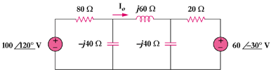

Figure 10.79
For Prob. 10.31.

